CS LAB Assignment 3

Abdul Moiz, 474550, ME-15B

Submission Date: 19-Oct-23

**TASK 1**

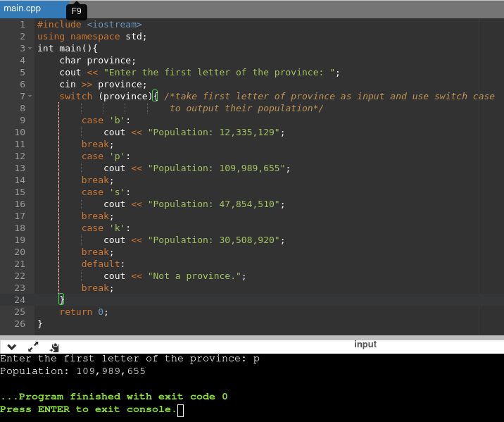

**TASK 2**

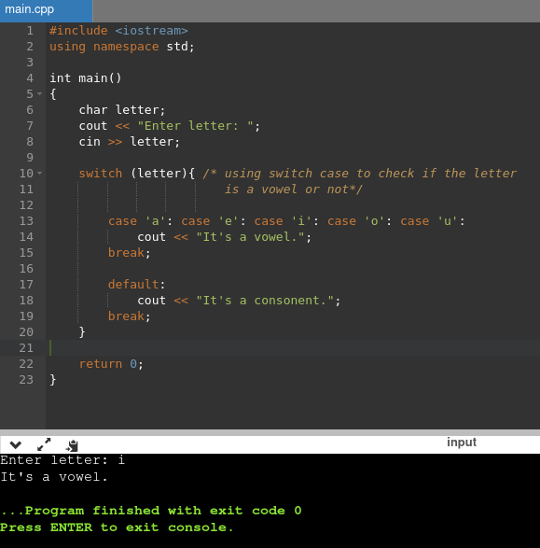

**TASK 3**

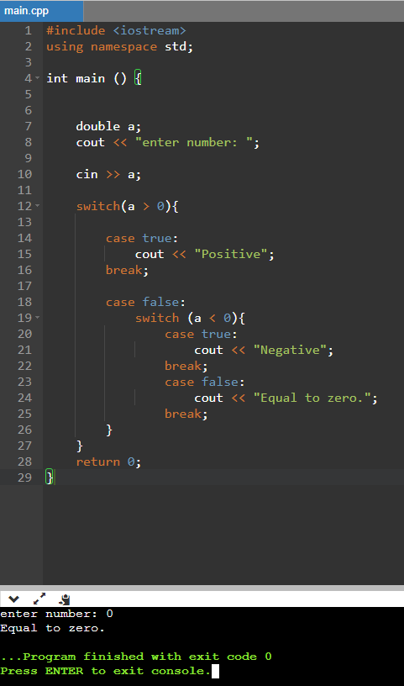

**TASK 4**

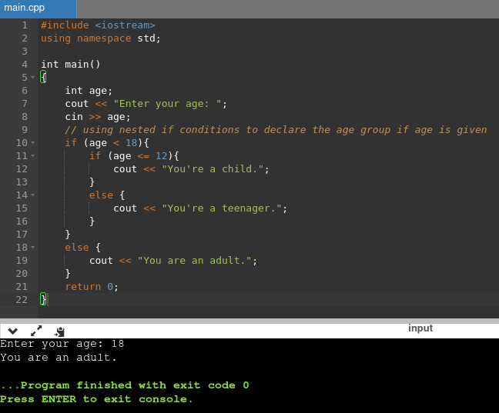

**TASK 5**

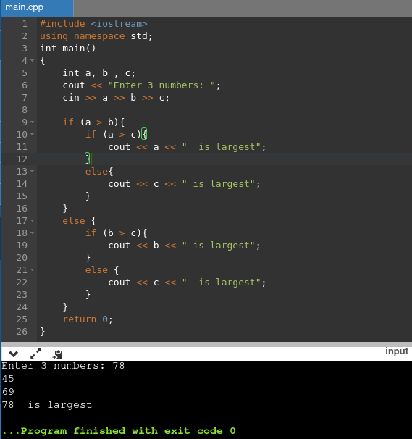

**TASK 6**

